Web Chatting Game
Project Technical Documentation
Autor: Erik Loskorikh

1. Project Overview
The Web Chatting Game is a browser-based multiplayer 2D social game where players move through an infinite apartment building, interact with other players and manage their own virtual apartments.

2. Target Audience
The game is designed for players interested in simple online social environments and communication. It can also serve as a demonstration project for web multiplayer architecture in educational environments.

3. System Analysis

3.1 Stakeholders
Player – interacts with the game world, chats with other users, and manages an apartment.
Administrator – moderates content, manages users, and ensures safe system operation.

3.2 Functional Requirements
FR‑01 Player login
FR‑02 Movement inside 2D building
FR‑03 Enter unlocked apartments
FR‑04 Lock personal apartment
FR‑05 Elevator travel between floors
FR‑06 Real‑time chat messaging
FR‑07 Messages displayed above characters
FR‑08 Character customization
FR‑09 Apartment customization
FR‑10 Administrator user moderation

4. Technologies Used
PHP – backend server logic
MySQL – relational database
HTML5 – structure of the web interface
CSS3 – styling and layout
JavaScript – game logic and UI interaction
WebSockets – real-time communication between server and clients

5. Multiplayer Communication (API)
The frontend and backend communicate using WebSockets. Data packets are exchanged in JSON format separated by newline characters. Each packet contains a field called 'type' which defines the packet purpose.

6. Game Design

6.1 Core Mechanics
• Player movement in top-down 2D world
• Real-time chat between players
• Personal apartments for each player
• Elevator travel between floors
• Character and apartment skins

6.2 Game Loop
Players spawn in their apartment, explore the building corridors, use the elevator to visit other floors and communicate with other players.

7. Visual Style
The game uses a 2D pixel-art style with a top-down camera perspective. This visual approach allows simple navigation and a retro aesthetic.

8. Use case
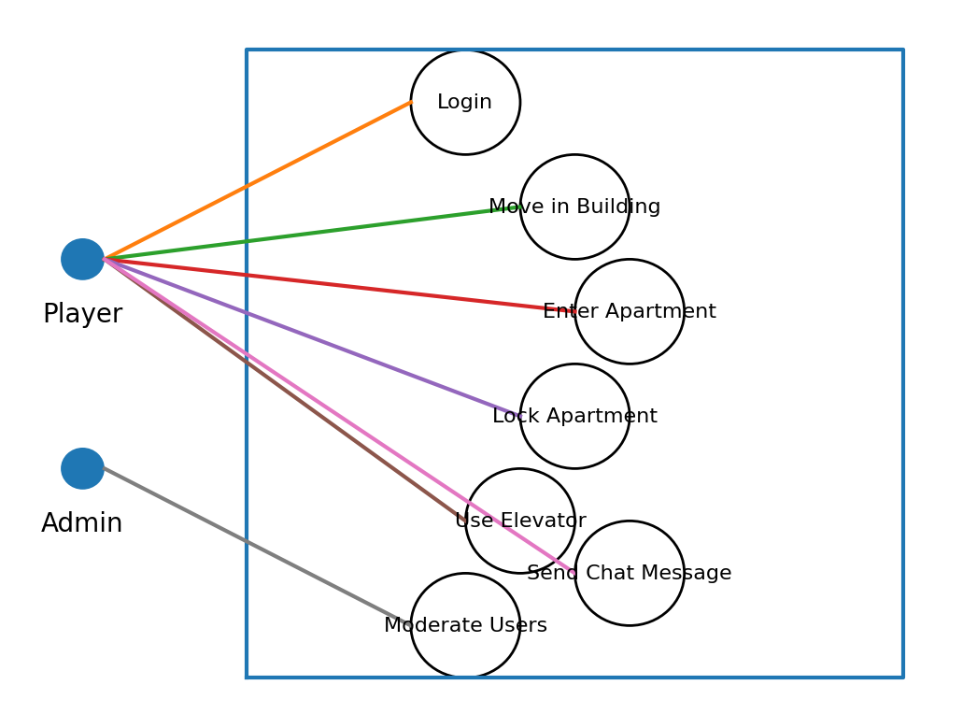

9. Class diagram
For better view click on link:
https://github.com/45676f725a75796576/web_chatting_game/blob/main/doc/classDiagram.md

